More Tips for Accessing the Newsletter

We have heard that some members are still having trouble viewing the Newsletter and some do not know it can actually be printed off from the website. It can be printed off and might be easier to read that way. Go to the Guild’s website (coastalquilters.org) and look at the left column on the Home Page to find the link. In the example below, it reads April 2014 Coast Lines (pdf).

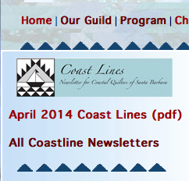

Click on the link, the Newsletter should open and you can print it off. Note that right below the link to the current issue, is a link – ALL COASTLINE NEWSLETTERS - which takes you to a page with links to previous issues of the Newsletter so if you have missed one or need to look something up, that is where you will find them.

If you are having trouble opening the Newsletter, here are some additional tips for getting it open:

If you have a PC, Internet Explorer is your Browser and you can not open the Newsletter (i.e. the document freezes), try another Browser. Members have had good luck using Mozilla Firefox or Google Chrome.

If you have a PC, Firefox is your Browser and you can only get one page of the Newsletter, try downloading the Newsletter to your desktop and then printing it off.

If you have a MAC with Safari as your Browser: in its newest format, Safari automatically displays the Newsletter file only. There are no icons to download or print. To download and print the file, you have to go to File > Export as PDF. It should then be saved to your desktop and you should be able to print it off.

If anyone continues to have problems viewing or printing the Newsletter, please send an email to Sue Kadner at cqginfo@gmail.com and specify Newsletter Problem in the Subject Line. We are really trying to make it easy for you to access the Newsletter and will work with you individually to make this happen.

